### [**Magnum P.I. - Episode 3.01 - Double Jeopardy - Promotional Photos + Press Release**](https://www.spoilertv.com/2020/11/magnum-pi-episode-301-double-jeopardy.html)

Posted by SpoilerTV at November 10, 2020 [**13 Comments**](https://www.spoilertv.com/2020/11/magnum-pi-episode-301-double-jeopardy.html#disqus_thread)

[MAGNUM P.I.](https://www.spoilertv.com/search/label/Magnum%20P.I.)

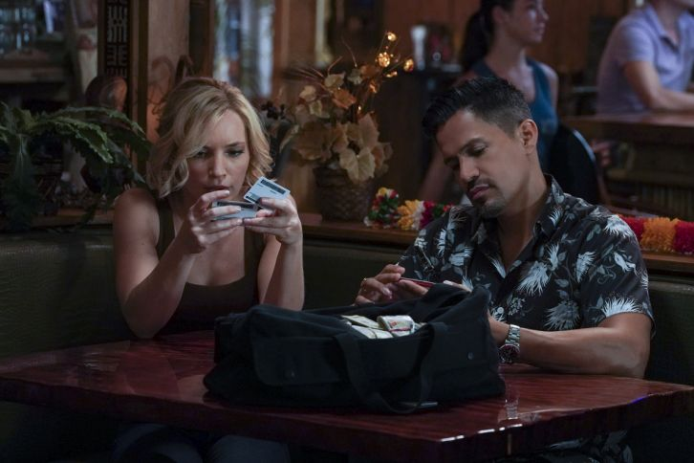

Promotional Photos

     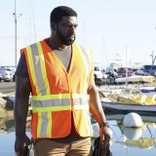  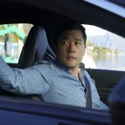 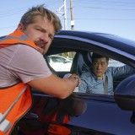       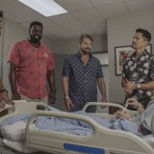   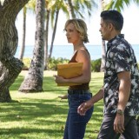

Press Release

MAGNUM AND HIGGINS’ NEW CLIENTS HIRE THEM TO FIND THEIR MISSING BROTHER, LEADING TO HIGGINS BEING SHOT AND TC ABDUCTED WHEN A SECRET CASE OF REVENGE IS REVEALED DURING THEIR INVESTIGATION, ON THE THIRD SEASON PREMIERE OF “MAGNUM P.I.,” FRIDAY, DEC. 4

“Double Jeopardy” – Magnum and Higgins’ new clients hire them to find their missing brother last seen on the island, leading to Higgins being shot and TC abducted when a secret case of revenge is revealed during the investigation. Also, Higgins (and Magnum!) are surprised when her surgeon asks her out, on the third season premiere of MAGNUM P.I., Friday, Dec. 4 (9:00-10:00 PM, ET/PT) on the CBS Television Network. “Hawaii Five-0’s” Kimee Balmilero and Shawn Garnett guest star.  
  
REGULAR CAST:  
Jay Hernandez (Thomas Magnum)  
Perdita Weeks (Juliet Higgins)  
Zachary Knighton (Orville “Rick” Wright)  
Stephen Hill (Theodore “TC” Calvin)  
Tim Kang (Det. Gordon Katsumoto)  
Amy Hill (Kumu)  
.  
GUEST CAST:  
Kimee Balmilero (Dr. Noelani Cunha)  
Shawn Garnett (Flippa)  
Jay Ali (Dr. Ethan Shah)  
Paola Nunez (Helen)  
Brian Letscher (Bruce)  
Kap Te’o-Tafiti (Shota)  
Juan-Pablo Veizaga (Max Martinez)  
Andrea Johnson (Anesthesiologist)  
Nikol Luoma (Nurse)  
Andre West (Dr. Alan Healy)  
Keola Simpson (HPD Sergeant)  
  
WRITTEN BY: Peter M. Lenkov & Eric Guggenheim  
  
DIRECTED BY: Bryan Spicer

SOURCE: [**CBS**](https://www.cbs.com/)